Mindmapping tools

Retrieved from http://freenuts.com/top-10-free-online-mind-mapping-tools/

As the name, mind mapping means that to draw your mind or ideas as a map, which are well-known for brainstorm, exploring your brain for many ideas.
For mind mapping, you can just use a pen and one paper, but it will be funny and easier if you are using below tools, which are all available for you to create mind maps online for free without anything to download or install.

1. Bubblus
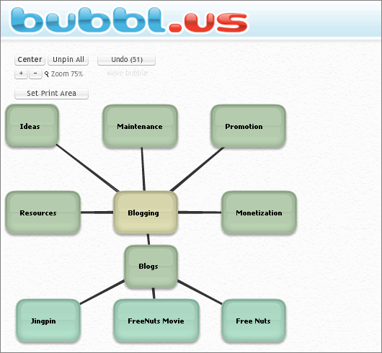
Bubblus is very simple and easy to use, you just need to enter and drag.
The mind maps can be exported as image, XML or HXML files, and you can also share the mind maps with your friends or embed them into your blogs.
Go to Bubblus

2. Mindomo
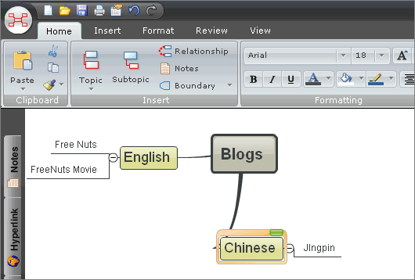
The mind mapping tool Mindomo lets you search YouTube videos, add images, videos or audio with the exist URLs, upload attachment, and add a lot of symbols.
You can export the mind map as PDF, Image, RTF and some other format files.
Go to Mindomo

3. MindMeister
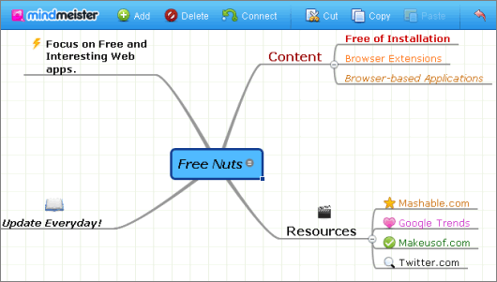
You can add many interesting icons on the Mind Map with MindMeister easily.
You can export the mind maps as image, RTF, PDF or some other format files.
Go to MindMeister

4. Mind42
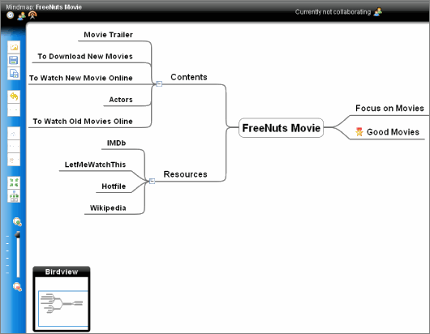
With Mind42, you can add icons, links and attachment easily.
You can download the mind maps as JPEG, PNG, RTF and some other format files.
Go to Mind42

5. Dabbleboard
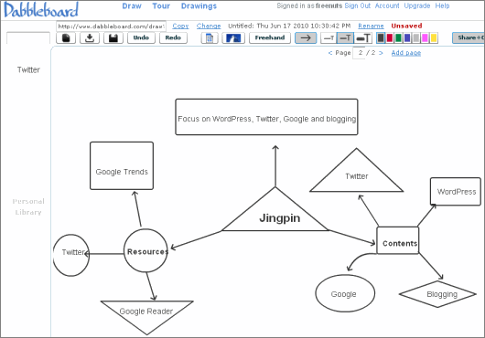
The Dabbleboard free online mind mapping tool allows you to draw different graphs manually and easily.
The mind maps are available for you to download as PNG files.
Go to Dabbleboard

6. Text 2 Mind Map
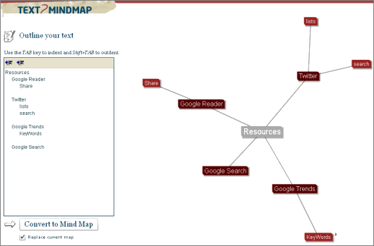
Enter your text in the left column on the text2mindmap website, then you can convert the text into a mind map in the right column.
And you can download the mind map as a JPG file.
Go to Text 2 Mind Map

7. WiseMapping
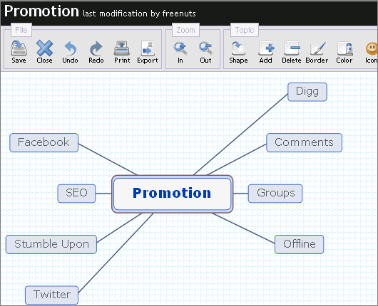
On the WiseMapping website, you can add topics with icons, notes or links easily.
And you can download the mind maps as SVG, PDF, Freemind or image files.
Go to WiseMapping

8. Ekpenso
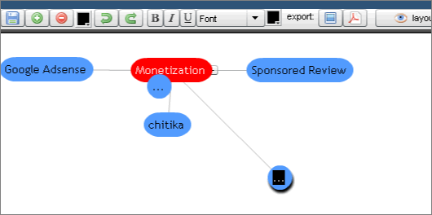
The Ekpenso website supports German, English, Chinese, Russian and Finnish.
And you can download the mind maps as PDF or PNG files.
Go to Ekpenso

9. Edistorm
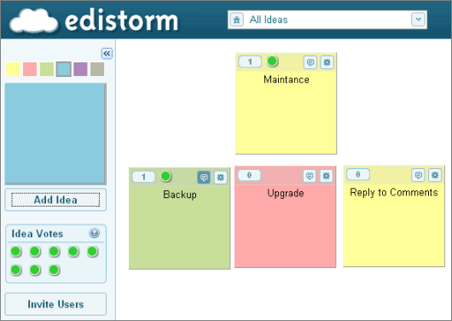
With the free online mind mapping tool Edistorm, you can add ideas one by one.
And you can download the mind maps as XLS or PDF files.
Go to Edistorm

10. Comapping
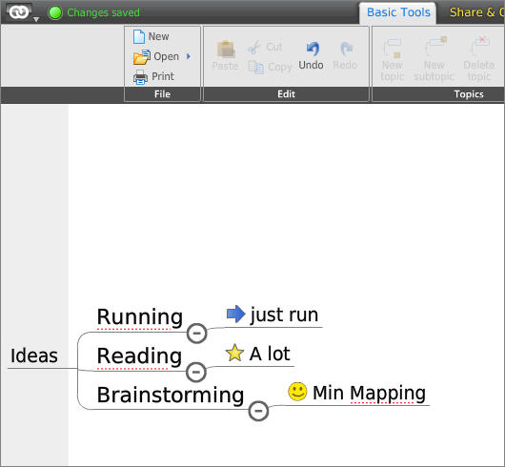
You can add topics, text or icons easily, and you also insert notes, tasks or maps.
Comapping will let you export the mind map in many formats, such as PDF, SVG, CSV, and so on.

